CZ1106 Tutorial FIVE

CONTROL FLOW CONSTRUCTS

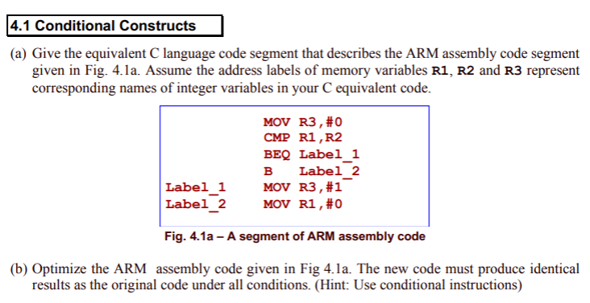

a)

R3 = 0;

if (R1 == R2)

{

R3 = 1;

}

R1 = 0; ✅

b)

MOV R3, #0

CMP R1, R2

MOVEQ R3, #1

MOV R1, #0 ✅

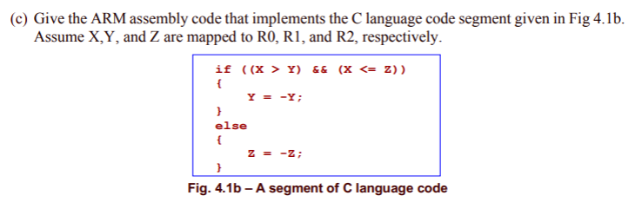

CMP R0, R1 ✅

BLE Skip ✅

CMP R0, R2 ✅

BGT Skip ❌

MVN R1, R1❌ MVNLE R1, R1

B Done ✅

Skip MVN R2, R2 ✅

Done ✅

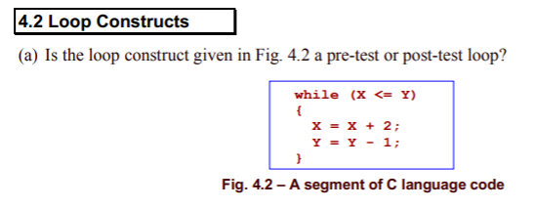

pre-test

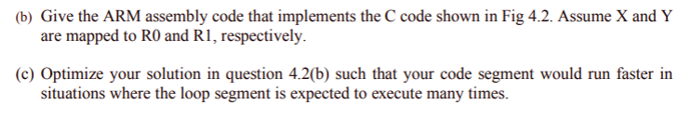

b)

Back CMP R0, R1

BGT Exit

ADD R0, R0, #2

SUB R1, R1, #1

B Back

Exit ✅

c) ❌use post-test loop.

CMP R0, R1

BGT Exit

Back ADD, R0, R0, #2

SUB R1, R1, #1

CMP R0, R1

BLE Back

Exit

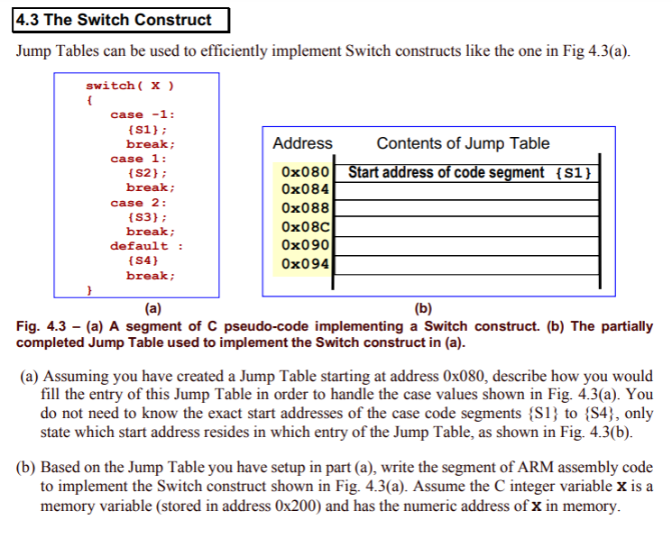

a)

0x088 ->S2 ✅

0x08C -> S3 ✅

S4??? ❌set all out of range values to be equivalent to x = 3. also set x=0 to be the “default”

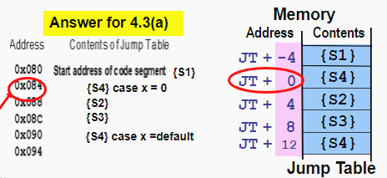

b)

MOV R1, #0x084

LDR PC, [R1, R2, LSL #2]

